

**5V Literature 2024-2025**

1. **Introduction of Literary history**
2. **Old English (ca. 500-1066): *Beowulf***
3. **Middle English (ca. 1066-1500): Chaucer’s *Canterbury Tales***
4. **Renaissance (1500-1660): Shakespeare’s *Shall I Compare Thee to a Summer’s Day***
5. **Age of Reason/Enlightenment (1660-1800): Daniel Defoe’s *Robinson Crusoe***
6. **Romantic Period (1798-1870): Edgar Allen Poe’s *Annabel Lee* & William Wordsworth’s *We Are Seven***
7. **Regency (1811-1820): Jane Austen’s *Pride & Prejudice***
8. **Victorian Period (1830-1900): Charles Dickens’ *Oliver Twist***
9. **Your own choice of pre-20th century novel**

**Introduction to literary history**

***“Tell me what you read and I will tell you who you are.”***

**Why we read and enjoy literature**

We read literature to learn more about ourselves and to make sense of the world around us. Good writing answers questions. Great writers know their readers and are familiar with the kind of questions they are likely to ask. The literature lessons in this course book help you to become more aware of the close relationship between writer, reader, culture and text.

Enjoying literature is like taking a grand tour through culture. You visit fictional worlds and make new friends who teach you to cross boundaries. Literature opens up so many doors for you. It reveals how others think. Reading literature allows you to empathise with other people, it can help you solve your problems and teaches you to see things differently.

Ineffective language weakens ideas. In literature all words and images matter. The famous author George Orwell explained it once like this: a good writer will ask himself at least four questions in every sentence – What am I trying to say? What words will express it? What image will make it clearer? Is this image fresh enough to have an effect?

It is not always easy to understand literary texts. But if you take the time to dig deeper into a text, you will discover that it can be very rewarding. Before anything else, reading literature improves your attention, concentration and memory skills. Furthermore, it triggers your imagination, and in addition to all other benefits, as recent research in cognitive science has demonstrated, deep reading – slow, immersive, rich in sensory detail and emotional and moral complexity – is a distinctive experience. It is much more than just decoding words. Deep reading allows you to remain fully immersed in the narrative and draws on the same brain regions that would be active if the literary scenes were unfolding in real life, thus increasing your reallife capacity for empathy.

**Why literature at school**

Literature is an effective tool for language learning, because literary texts provide rich linguistic input and they stimulate you to use your imagination. You learn to express yourself in a foreign language. As a bonus, you also gain more insight into the various literary devices and literary periods.

By reading a great variety of literary texts, you will learn to explore the different ways in which these texts can be read and understood. The selected texts deal with universal themes such as love, loss, isolation and growing up. They take a central position in the literature lessons and are examples of great literature, written in English through the ages.

Now watch the video: why we read literature:

<https://www.youtube.com/watch?v=MSYw502dJNY&t=2s>

**Old English Period**

***Beowulf***

**History**

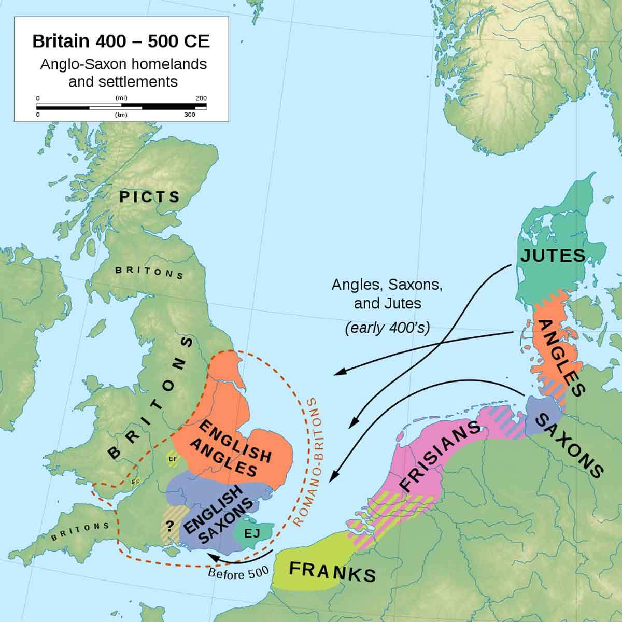The Anglo-Saxon period in Britain spans approximately the six centuries from 410-1066AD. The period used to be known as the Dark Ages, mainly because written sources for the early years of Saxon invasion are scarce. However, most historians now prefer the terms 'early middle ages' or 'early medieval period'.

When the Roman legions left Britain, the Germanic-speaking Angles, Saxons, Jutes and Frisians began to arrive – at first in small invading parties, but soon in increasing numbers. It was a time of war, of the breaking up of Roman Britannia into several separate kingdoms, of religious conversion and, after the 790s, of continual battles against a new set of invaders: [the Vikings](https://www.history.org.uk/primary/resource/3867/vikings-a-brief-history).

**Language**

Old English, or Anglo-Saxon, is the earliest recorded form of the [English language](https://en.wikipedia.org/wiki/English_language), spoken in [England](https://en.wikipedia.org/wiki/England) and southern and eastern [Scotland](https://en.wikipedia.org/wiki/Scotland) in the [early](https://en.wikipedia.org/wiki/Early_Middle_Ages) [Middle Ages](https://en.wikipedia.org/wiki/Middle_Ages). It developed from the languages brought to [Great Britain](https://en.wikipedia.org/wiki/Great_Britain) by [Anglo-Saxon settlers](https://en.wikipedia.org/wiki/Anglo-Saxon_settlement_of_Britain) in the mid-5th century, and the first [Old English literary works](https://en.wikipedia.org/wiki/Old_English_literature) date from the mid-7th century. After the [Norman conquest](https://en.wikipedia.org/wiki/Norman_conquest) of 1066, English was replaced, for a time, by [Anglo-Norman](https://en.wikipedia.org/wiki/Anglo-Norman_language) (a [relative of French](https://en.wikipedia.org/wiki/Langues_d%27o%C3%AFl)) as the language of the upper classes. This is regarded as marking the end of the Old English era, since during this period the English language was heavily influenced by Anglo-Norman, developing into a phase known now as [Middle English](https://en.wikipedia.org/wiki/Middle_English) in England and [Early Scots](https://en.wikipedia.org/wiki/Early_Scots) in [Scotland](https://en.wikipedia.org/wiki/Scotland).

Old English is one of the [West Germanic languages](https://en.wikipedia.org/wiki/West_Germanic_languages). Like other old Germanic languages, it is very different from Modern English and Modern Scots, and largely incomprehensible for Modern English or Modern Scots speakers without study.

**Literary characteristics**

The Old English poetry which has received the most attention deals with what has been termed the Germanic **heroic** past, talking about **heroes and kings.**

The most distinguishing feature of Old English poetry is its [**alliterative verse**](https://en.wikipedia.org/wiki/Alliterative_verse)**style**. Old English poetry alliterates, meaning that a sound (usually the initial stressed consonant sound) is repeated throughout a line.

Even though all extant Old English poetry is written and literate, many scholars propose that Old English poetry was an **oral craft** that was performed by a *poet* and accompanied by a [harp](https://en.wikipedia.org/wiki/Harp).

***Beowulf***

*Beowulf* is an Old English [epic poem](https://en.wikipedia.org/wiki/Epic_poetry) in the tradition of [Germanic heroic legend](https://en.wikipedia.org/wiki/Germanic_heroic_legend) consisting of 3,182 [alliterative lines](https://en.wikipedia.org/wiki/Alliterative_verse)[1]. It is one of the most important and [most often translated](https://en.wikipedia.org/wiki/List_of_translations_of_Beowulf) works of [Old English literature](https://en.wikipedia.org/wiki/Old_English_literature). The date of composition is a matter of contention among scholars; the only certain dating is for the manuscript, which was produced between 975 and 1025. Scholars call the anonymous author the "*Beowulf* poet".The story is set in pagan [Scandinavia](https://en.wikipedia.org/wiki/Scandinavia) in the 6th century. [Beowulf](https://en.wikipedia.org/wiki/Beowulf_(hero)), a hero of the [Geats](https://en.wikipedia.org/wiki/Geats), comes to the aid of [Hrothgar](https://en.wikipedia.org/wiki/Hrothgar), the king of the [Danes](https://en.wikipedia.org/wiki/Danes_(Germanic_tribe)), whose [mead hall](https://en.wikipedia.org/wiki/Mead_hall)[2] in [Heorot](https://en.wikipedia.org/wiki/Heorot) has been under attack by the monster [Grendel](https://en.wikipedia.org/wiki/Grendel). After Beowulf slays him, [Grendel's mother](https://en.wikipedia.org/wiki/Grendel%27s_mother) attacks the hall and is then defeated. Victorious, Beowulf goes home to Geatland and becomes king of the Geats. Fifty years later, Beowulf defeats a [dragon](https://en.wikipedia.org/wiki/The_Dragon_(Beowulf)), but is mortally wounded in the battle. After his death, his attendants cremate his body and erect a barrow[3] on a headland in his memory.

**Assignments**

Before you read the modern English version of the introduction*,*first try to read the Old English version.

**The introduction of Beowulf, Old English version**

The story opens in Denmark, where Grendel is terrorising one of the kingdoms. The Swedish prince Beowulf hears of his neighbours’ troubles and he decides to sail to their aid. This is the first part of the original Beowulf text:

# **Beowulf (Old English version)**

Hwæt. We Gardena in geardagum,

þeodcyninga, þrym gefrunon,

hu ða æþelingas ellen fremedon.

Oft Scyld Scefing sceaþena þreatum,

monegum mægþum, meodosetla ofteah,

egsode eorlas. Syððan ærest wearð

feasceaft funden, he þæs frofre gebad,

weox under wolcnum, weorðmyndum þah,

oðþæt him æghwylc þara ymbsittendra

ofer hronrade hyran scolde,

gomban gyldan. þæt wæs god cyning.

ðæm eafera wæs æfter cenned,

geong in geardum, þone god sende

folce to frofre; fyrenðearfe ongeat

þe hie ær drugon aldorlease

lange hwile. Him þæs liffrea,

wuldres wealdend, woroldare forgeaf;

Beowulf wæs breme blæd wide sprang,

Scyldes eafera Scedelandum in.

***Beowulf (modern English)***

So. The Spear-Danes in days done by

And the kings who ruled them had courage and greatness.

We have heard of those prince’s heroic campaigns.

There was Shield Sheafson, scourge of many tribes,

A wrecker of mead-benches, rampaging among foes.

This terror of the hall-troops had come far.

A foundling to start with, he would flourish later on

As his powers waxed and his worth was proved.

In the end each clan on the outlying coats

Beyond the whale-road had to yield to him

And begin to pay tribute. That was one good king.

Afterwards a boy-child was born to Shield,

A cub in the yard, a comfort sent

By God to that nation. He knew what they had tholed,

The long times and troubles they’d come through

Without a leader; so the Lord of Life,

The glorious Almighty, made this man renowned.

Shield had fathered a famous son:

Beow’s name was known through the north …

1. In the manuscript, the character of Beowulf’s father Shield is presented in strong descriptive words, through direct characterisation. Quote two powerful nouns or adjectives describing him.
2. Is Shield's character also described in an indirect way? Explain your answer.
3. Was Shield born into power? Use a quote to explain your answer.
4. Was Beowulf born into power? Use a quote to explain your answer.

2. Read *Repetition and alliteration* below*.*

When you look at the Old English manuscript you see many alliterations. Choose all alliterations in the first five lines. Note: Hw in *Hwæt* also sounds like a g...

Wé Gárdenain géardagum

þéodcyninga þrym gefrúnon·

hú ðá æþelingas ellen fremedon.

Oft Scyld Scéfing sceaþena þréatum

monegum maégþum meodosetla oftéah·

**Repetition and alliteration**

**Repetition** is a literary technique that writers use by repeating the same words or phrases a few times to make an idea clearer or to add more power to a story.

**Alliteration** is the repetition of letters at the beginning of words – in prose words that are near each other in a sentence and in poetry words that are near each other in poetry lines. Alliteration can create a musical or a comical effect (Bob’s Burgers, Phineas and Ferb, SpongeBob SquarePants). Many nursery rhymes contain alliteration, because people remember alliterative phrases more easily, for example: Peter Piper picked a peck of pickled peppers, by Mother Goose. Advertisers use alliteration to create witty and memorable catchphrases and tag lines.

**Middle English Period**

**Geoffrey Chaucer’s *Canterbury Tales***

**History**

In 1066, [William, Duke of Normandy](https://en.wikipedia.org/wiki/William_the_Conqueror), took advantage of the English succession crisis[4] to begin the [Norman[5] Conquest](https://en.wikipedia.org/wiki/Norman_Conquest). With an army of [Norman followers](https://en.wikipedia.org/wiki/Normans) and mercenaries, he defeated Harold[6] at the [Battle of Hastings](https://en.wikipedia.org/wiki/Battle_of_Hastings) on 14 October 1066 and rapidly occupied the south of England. William used a network of [castles](https://en.wikipedia.org/wiki/Castle) to control the major centres of power, granting extensive lands to his main Norman followers and co-opting or eliminating the former Anglo-Saxon elite.

In the Middle Ages society was made up of the three orders, the clergy (the first class – a powerful political class, well educated), the nobility (the second class – an influential class with strong military power) and the people (the third class – the tax paying bourgeoisie, peasants and serfs). Each order had its own responsibilities, privileges and special honours.

In the fourteenth century the new culture of reading and writing spread predominantly among the bourgeoisie, the citizens who made a living either from trade or from craft.

The nobility kept amusing themselves at hunting and dancing. Because of the widespread illiteracy, most stories were still told instead of read towards the end of the Middle Ages. Professional storytellers travelled from town to town bringing tales, the latest news from the royal courts and musical entertainment.

Around 1440, Johann Gutenberg, of Strasburg in Germany, invented the printing press with movable types and made it possible to multiply books. At the same time Chaucer arrived, and he set the new standard: no more writing in dialect, but English as a literary language and English society as a topic. In The Canterbury Tales he painted the men and women of his day.

**Literary characteristics**

* French influences
* **End rhyme** instead of alliteration
* More **refined themes**: courtly love instead of death, war and glory
* More prominent **position for women**
* **Ideal is knight**, not warrior
* **Ballads** become popular, stories about King Arthur and his Knights of the round table
* Invention of the **printing press**

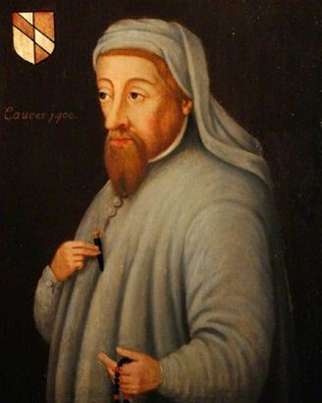**Geoffrey Chaucer’s *The Canterbury Tales***

The most important poet of the Middle English period is Geoffrey Chaucer (c. 1340-1400).

His greatest work is *The Canterbury Tales,* a frame story[7] in which he introduces us to a company of twenty-nine pilgrims who have come together at a London inn. They are preparing to go on a pilgrimage to the grave of Archbishop Thomas Becket, who had been murdered by knights of king Henry II in 1170, and made a saint three years later. They agree to hold a story-telling contest, and the winner will be treated to a free dinner. The innkeeper is to accompany them and act as judge. His account of the rules of the game makes us realize what a gigantic project Chaucer must originally have had in mind: each pilgrim was to tell two tales on the way to Canterbury, and another two on the way back, which would bring the total number of tales to some hundred and twenty. It is hardly surprising that the work remained unfinished. Apart from the Prologue we have twenty-four Tales, some of which are incomplete. But even these, with their great variety, their sharp observation and their humour are enough to give Chaucer a permanent place among the great English poets.

The General Prologue is Chaucer’s portrait gallery of pilgrims. In passages ranging  
from five or six lines to well over sixty, he brings them to life, giving us details about their  
appearance, their background, way of life and ideas. He pretends to admire every single  
one of them, no matter how bad they may be. But for the careful reader there is always a  
gentle irony that exposes them for what they really are, and in this way *The Canterbury*  
*Tales* becomes a fascinating panorama of medieval society.

The group of pilgrims leaving their inn at Southwark for Canterbury is led by the Knight,  
who is highest in rank and social status. Chaucer pictures him as a truly noble figure, who  
has fought for the Christian faith in many places in Europe and Africa. He is accompanied  
by his son, the Squire. A squire, in Chaucer’s days, was a young man of noble birth  
preparing to be a knight. For several years he had to serve as a page, and later as a squire,  
and it was not until he had proved his worth that he would receive his knighthood from  
the king. Unlike his father, who is only concerned with warfare, the Squire is engaged in a  
variety of other ways. He is both a soldier and a lover, and he hopes that brave deeds on  
the battlefield will help him in winning his lady’s favour (I. 10), and his amorous activities  
often prevent him from sleeping (II. 19-20). He is the perfect example of the courtly lover.

His many talents earn him the admiration not only of Chaucer himself, but  
also of the rest of the company.

|  |  |
| --- | --- |
| **The Squire**  With hym ther was his sone, a yong squier,  A lovyere and a lusty bacheler,  With lokkes crulle as they were leyd in presse.  Of twenty yeer of age he was, I gesse. Of his stature he was of evene lengthe,  And wonderly delyvere, and of greet strengthe.  And he hadde been somtyme in chyvachie In Flaundres, in Artoys, and Pycardie,  And born hym weel, as of so litel space, In hope to stonden in his lady grace.  Embrouded was he, as it were a meede AI ful of fresshe floures, whyte and reede.  Syngynge he was, or floytynge, al the day;  He was as fressh as is the month of May. Short was his gowne, with sleves longe and wyde;  Wel koude he sitte on hors and faire ryde.  He koude songes make and wel endite,  Juste and eek daunce, and weel purtreye and write.  So hoote he lovede that by nyghtertale  He sleep namoore than dooth a nyghtyngale.  Curteis he was, lowely, and servysable,  And carf biforn his fader at the table.  General Prologue, II. 79-100 | He had his son with him, a fine young squire,  A lover and cadet, a lad of fire  With locks as curly as if they had been pressed.  He was some twenty years of age, I guessed.  In stature he was of moderate length,  With wonderful agility and strength.  He'd seen some service with the cavalry In Flanders and Artois and Picardy  And had done valiantly in little space of time, in hope to win his lady's grace.  He was embroidered like a meadow bright And full of freshest flowers, red and white.  Singing he was, or fluting all the day;  He was as fresh as is the month of May.  Short was his gown, the sleeves were long and wide;  He knew the way to sit a horse and ride.  He could make songs and poems and recite,  Knew how to joust and dance, to draw and write. He loved so hotly that till dawn grew pale  He slept as little as a nightingale.  Courteous he was, lowly and serviceable,  And carved to serve his father at the table.  translation Nevill Coghill |

**Assignments**

**Assignment 1** Make a list of three qualities of body and three of mind that Chaucer brings out in this description.

The Monk is one of the many figures in the General Prologue connected with the church. Monks were supposed to live within a monastery, devoting their lives wholly to the service of God. St. Benedict, St. Maurus and St. Augustine were famous Church authorities who, at various times, had written instructions concerning monastic life, e.g. the ‘Rule’ of St. Benedict, l.9). They all stressed the importance of poverty and simplicity. The monastery with its fields and gardens provided the monks with all they needed, and their day was to be divided between prayer and meditation, and working the land. Chaucer’s Monk is an ‘outridere’, whose duty it was to look after the monastic estates. Occasionally his job took him outside the monastery, which explains his presence here.

|  |  |
| --- | --- |
| **The Monk**  A Monk there was, one of the finest sort  Who rode the country; hunting was his sport.  A manly man, to be an Abbot able°;  Many a dainty0 horse he had in stable.  His bridle0, when he rode, a man might hear  Jingling0 in a whistling wind as clear,  Aye, and as loud as does the chapel bell  Where my lord Monk was Prior of the cell.  The Rule of good St. Benet or St. Maur  As old and strict he tended to ignore;  He let go by the things of yesterday  And took the modern world’s more spacious way. He did not rate° that text a plucked hen  Which says that hunters are not holy men is  And that a monk uncloistered0 is a mere  Fish out of water, flapping on the pier,  That is to say, a monk out of his cloister.  That was a text he held not worth an oyster;  And I agreed and said his views were sound;  Was he to study till his head went round  Poring over books in cloisters? Must he toil  As Austin bade and till the very soil0?  Was he to leave the world upon the shelf?  Let Austin have his labour to himself.  This Monk was therefore a good man to horse;  Greyhounds he had, as swift as birds, to course0.  Hunting a hare or riding at a fence°  Was all his fun, he spared for no expense.  (...) Supple his boots, his horse in fine condition.  He was a prelate fit for exhibition0.  He was not like a pale tormented soul.  He liked a fat swan best, and roasted whole.  His palffey0 was as brown as is a berry.  General Prologue, II. 165-192, 203-207 translation Nevill Coghiil | fit to be an abbot (abt)  fine  *hoofdstel*  *rinkelen*  did not value at all  outside the monastery  work the field  hunt  *hindernis*  good enough to be shown  riding horse |

**Assignment** **2** Chaucer’s way of describing his pilgrims is one of seeming objectivity: he mentions facts and represents opinions, leaving it to the reader to draw their conclusions. It is only when we realize that by stressing certain points, and perhaps not mentioning others that may be just as important, Chaucer’s pictures are in fact far from objective.

Write a portrait of the Monk as Chaucer wants us to see him. Does Chaucer really agree with him, and believe that his views are sound? Illustrate from the text as much as possible.

**Assignment 3** Compare the portrait of the Squire with that of the Monk. Do you think Chaucer’s attitude towards the Squire is different from his attitude towards the Monk? If so, in what respects?

**Renaissance**

**Shakespeare’s *Shall I Compare Thee to a Summer’s Day***

# **History**

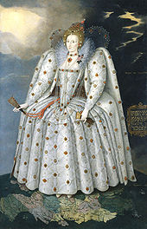Around 1500 English history entered upon a new and important phase: the Renaissance. This does not mean, of course, that society took on an entirely new aspect in that particular year. Many of the features that we now call typical of the Renaissance period had their roots in the Middle Ages; but it was not until the early sixteenth century that these new developments had become sufficiently strong to affect the character of society as a whole.

The word ‘Renaissance’ means ‘rebirth’, and the term is mostly used to refer to the renewed interest in the cultures of ancient Greece and Rome that arose at the time. The works of the great classical authors had never been wholly forgotten, but they had been looked upon primarily as the products of a civilization that was pagan in character, and therefore to be rejected. When Renaissance scholars set out to study classical culture, they did so with an open mind, casting off the prejudices of medieval Christianity. For them Greek and Roman culture came to be an ideal, an example to be applied to their own times, and classical influence can be seen in many forms of Renaissance art and thought. Among the most prominent of these *humanists,* as they came to be called, were the Dutchman Erasmus and the Englishman Thomas More, whose description of an ideal society *Utopia* is still widely read today.

In a wider sense the term ‘rebirth’ points to a number of fundamental changes in the way man looked upon himself and upon his place in the world around him. The nature of these changes may perhaps be brought out most clearly by comparing medieval and Renaissance ideas. In the developments outlined below, the first key phrase refers to the Middle Ages, the second to the Renaissance.

*1* *From a collective to an individual attitude*

In the Middle Ages people were seen, and saw themselves, as members of a larger body: they belonged to a family, a guild, a religious community, a nation. Gradually, however, man came to view himself as an individual being, whose thoughts, feelings and actions had a value and an importance of their own. This growing self-awareness is reflected in many areas. In religion, it led to the Reformation and the rise of Protestantism, with its emphasis on the individual relation between man and God. It is also seen in the beginnings of the capitalist system, based on private enterprise and the interests of the individual merchant. In the arts, too, we find a growing self-consciousness. Most medieval art had been anonymous, but the Renaissance artist saw his work as a personal achievement, and proudly attached his name to it. The emphasis on individual ability led to a desire to develop one’s talents in every possible direction. The ideal Renaissance man was expected to be a soldier, a poet, a hunter, a scholar and a musician in one.

1. *From a theocentric ('God-centred') to an ’anthropocentric’ ('man-centred’) outlook*

One of the first things that a reading of, for example, Chaucer’s Prologue to *The Canterbury Tales* will make clear, is how important the role of the Church in medieval society was. Man was constantly reminded that life on earth was but a preparation for death and the judgment to come, which would send him either to heaven or to hell. In the Renaissance religion had by no means disappeared; but the description of the period as 'the discovery of man and the world’ indicates that the idea of death no longer prevented man from exploring and enjoying life as fully as possible. The famous Renaissance motto *carpe diem* ('seize the day’) is not the opposite of the medieval *memento mori;* rather it is its result. It was *because* Renaissance man was acutely aware that all men must die that he was determined to make the most of life.

1. *From dogmatic belief to critical investigation*

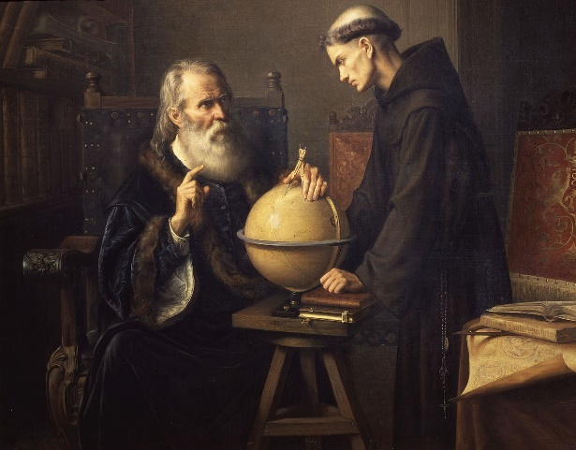Medieval ideas about man and the world around him were relatively static. The great truths were held by the Church, which provided religious explanations for most things, and there could be no questioning of these official doctrines. In the Renaissance, however, we find a growing desire for intellectual indepen­dence. Scholars and scientists were no longer prepared to accept the explana­tions offered by the Church uncritically. They insisted on basing their views not on authority, but on their own investigations. A crucial role in this revival oflearning was played by the new printing press, introduced in England at the end of the fifteenth century. It now became possible to spread ideas over a larger area at a low cost, and in the communication of ideas it soon proved to be of tremendous importance. Almost inevitably this attitude led to conflicts with the Church, as in the famous case of Galilei, whose theory that the earth revolves round the sun was in direct contrast with the official view that the earth formed the centre of the universe. But although Galilei was sentenced to imprisonment on account of his views, the Church eventually lost its authority in matters of Science. And it is in this rejection of authority and the insistence that conclusions should be based on experiments only that we find the beginnings of Science in the modern sense of the word.

**Literary characteristics**

* Renewed interest in **Ancient Roman and Greek cultures** (seen as pagan in Middle Ages)
* **Antropomorphic (man-centred)** instead of theocentric (god-centred)
* **Individual attitude** instead of collective
* **Critical investigation** instead of dogmatic belief
* Rise of the **printing press**

**William Shakespeare**

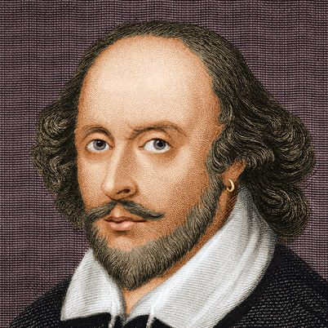

William Shakespeare was an English poet, playwright, and actor of the Renaissance era. He was an important member of the King’s Men theatrical company from roughly 1594 onward. Known throughout the world, Shakespeare’s works—at least 37 plays, 154 sonnets, and 2 narrative poems—capture the range of human emotion and conflict and have been celebrated for more than 400 years. Details about his personal life are limited, though some believe he was born and died on the same day, April 23, 52 years apart (1564-1616).

Shakespeare wrote 154 sonnets published in his ‘quarto’ in 1609, covering themes such as the passage of time, mortality, love, beauty, infidelity, and jealousy. The first 126 of Shakespeare’s sonnets are addressed to a young man, and the last 28 addressed to a woman – a mysterious ‘dark lady’.

**Sonnet 18**

Shall I compare thee to a summer’s day?

Thou art more lovely and more temperate

Rough-winds do shake the darling buds of May

And summer’s lease hath all too short a date:

Sometime too hot the eye of heaven shines,

And often is his gold complexion dimmed,

And every fair from fair sometime declines

By chance, or nature’s changing course untrimmed:

But thy eternal summer shall not fade,  
Nor lose possession of that fair thou ow’st

Nor shall Death brag thou wander’st in his shade,

When in eternal lines to time thou grow’st:

So long as men can breathe or eyes can see,

So long lives this, and this gives life to thee.

**Assignments**

1. a Whom does Shakespeare indicate by words like ‘thee’, ‘thou’ and ‘thy’?

b What is obviously meant by ‘the eye of heaven’?

c What other reference is there to the same idea in the poem?

1. a The ‘thee’ of line 1 compares favourably with an English summer day. Mention 3 points that illustrate this.

b How is the weather compared to the mood of Shakespeare’s beloved?

1. In line 7 the word ‘fair’ is used in the sense of ‘beautiful’.

a What does Shakespeare mean here?

b In what two ways may this change take place?

c Give one example each, from the text, of how this might work out in

nature.

d How can this change be applied to people?

1. As you should know, a sonnet is usually subdivided into an octave and a sestet, with a clear break in between (volta of chute). The octave and the sestet are generally divided into two quatrains and two tercets. In a Shakespearian sonnet, however, you generally find a subdivision of the sestet into one quatrain and one couplet.

a What is the subject of the octave and what of the sestet?

b What is the function of the couplet?

c The word “ow’st” is a form of either the verb “ to own” (bezitten) or “ to owe” (schuldig zijn). Of which of these two is it a form and explain why you think so.

1. a To what aspect of summer does he contrast his beloved in line 9?

b When could one say that one wanders in the shade of Death (line 11)?

c Why is ‘Death’ spelled with a capital letter?

d How can a mortal man, Shakespeare, say that the beauty of his beloved will be eternal?

e Does Shakespeare express his opinion about his own poetry anywhere?

f What is meant by ‘this’ in the last line?

g Do you think there is a grain of truth in Shakespeare’s claim that hehas made the person he loves eternal?

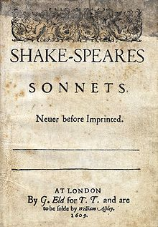

**Age of Reason/Enlightenment**

**Daniel Defoe’s *Robinson Crusoe***

**History**

During this *Age of Reason* people strongly believed in the power of critical thinking. Religious and political leaders began losing their influence on society. Logic and progress in science were seen as the answers to all life’s great questions of freedom, democracy and fundamental rights. The Age of Enlightenment enriched religious and philosophical understanding, resulting in masterpieces written by David Hume, Immanuel Kant, and Jean-Jacques Rousseau.  
  
The 18th century offered a wealth of knowledge, exploration and rapidly growing technology. Britain had become a rich nation thanks to its trade. The invention of machinery resulted in the founding of new factories in cities like Birmingham, Glasgow, Manchester and Liverpool. During this period, England was one of the most advanced economies in the world.

**Literary Characteristics**

The middle classes, especially women, started reading books. They bought them or borrowed them from libraries. The novel became the leading genre of the Enlightenment. These were mostly morally uplifting and instructive novels promoting virtue, good sense, and universal benevolence, and introducing heroes who were no longer princes but representatives of the middle class.

Daniel Defoe (1660–1731) and Jonathan Swift were among the prominent English writers of the Enlightenment period. Defoe's Robinson Crusoe (1719) and Moll Flanders (1722), and Swift's Gulliver's Travels (1726) are examples of how writers of the Enlightenment era attempted to educate and inform the public. As an Irish-English author,Swift's satirical [prose](https://app.studysmarter.de/link-to?studyset=5668818&summary=36544792&language=en&amp_device_id=dLIA2bPHDIu9ToZx2ZxB1h) on different topics, including ethics and politics in society and the ill-treatment of the Irish.

The Enlightenment writers challenged the authority of religion and government. Through their works, they became vocal opponents of censorship and constraints on individual freedom and, especially, interference of the Church in civil society. These issues became the thematic concern for many writers during the Enlightenment, including Jonathan Swift and Alexander Pope, culminating in what is known as the Golden Age of Satire[8] (late seventeenth and early eighteenth centuries).

**Daniel Defoe’s *Robinson Crusoe***

In the original story of Robinson Crusoe, Daniel Defoe pictures a typical 18th century middle class main character who decides to break free of his family and the middle class society they live in. Crusoe escapes his pre-arranged life and the constraints of English society.

The adventures of Robinson Crusoe have been rediscovered, retold and reinterpreted through generations. Since its publication in 1719, the story has gone through hundreds of different versions and has been translated over and over again. It has been rendered into films, poems, pantomimes, shows and an opera by Offenbach. During this process of retelling and reinterpreting, many original story details have changed, resulting in a hero of almost mythic proportions.

**Fragment 1**

**from chapter 1 – Start in life**

*At the beginning of the novel, Crusoe breaks free of his family and the middle class society they live in. He escapes his pre-arranged life and the constraints of English society.*

I was born in the year 1632, in the city of York, of a good family, though not of that country, my father being a foreigner of Bremen, who settled first at Hull. He got a good estate by merchandise, and leaving off his trade, lived afterwards at York, from whence he had married my mother, whose relations were named Robinson, a very good family in that country, and from whom I was called Robinson Kreutznaer; but, by the usual corruption of words in England, we are now called – nay we call ourselves and write our name – Crusoe; and so my companions always called me.

I had two elder brothers, one of whom was lieutenant-colonel to an English regiment of foot[9] in Flanders, formerly commanded by the famous Colonel Lockhart, and was killed at the battle near Dunkirk against the Spaniards. What became of my second brother I never knew, any more than my father or mother knew what became of me.

Being the third son of the family and not bred to any trade, my head began to be filled very early with rambling thoughts. My father, who was very ancient, had given me a competent share of learning, as far as house-education and a country free school generally go, and designed me for the law; but I would be satisfied with nothing but going to sea; and my inclination to this led me so strongly against the will, nay, the commands of my father, and against all the entreaties and persuasions of my mother and other friends, that there seemed to be something fatal in that propensity of nature, tending directly to the life of misery which was to befall me.

My father, a wise and grave man, gave me serious and excellent counsel against what he foresaw was my design. He called me one morning into his chamber, where he was confined by the gout[10], and expostulated[11] very warmly with me upon this subject. He asked me what reasons, more than a mere wandering inclination, I had for leaving father’s house and my native country, where I might be well introduced, and had a prospect of raising my fortune by application and industry, with a life of ease and pleasure. He told me it was men of desperate fortunes on one hand, or of aspiring, superior fortunes on the other, who went abroad upon adventures, to rise by enterprise, and make themselves famous in undertakings of a nature out of the common road; that these things were all either too far above me or too far below me; that mine was the middle state, or what might be called the upper station of low life, which he had found, by long experience, was the best state in the world, the most suited to human happiness, not exposed to the miseries and hardships, the labour and sufferings of the mechanic part of mankind, and not embarrassed with the pride, luxury, ambition, and envy of the upper part of mankind. He told me I might judge of the happiness of this state by this one thing – viz[12]. that this was the state of life which all other people envied; that kings have frequently lamented[13] the miserable consequence of being born to great things, and wished they had been placed in the middle of the two extremes, between the mean and the great; that the wise man gave his testimony to this, as the standard of felicity, when he prayed to have neither poverty nor riches.

**Fragment 2**

**from chapter 3 – Wrecked on a desert island**

*In chapter 3, Crusoe sets sail again, only to be shipwrecked on a desert island. He recounts: ‘I went on board in an evil hour, the 1st September 1659, being the same day eight years that I went from my father and mother at Hull, in order to act the rebel to their authority, and the fool to my own interests.’*

We had another boat on board, but how to get her off into the sea was a doubtful thing. However, there was no time to debate, for we fancied that the ship would break in pieces every minute, and some told us she was actually broken already.

In this distress the mate of our vessel laid hold of the boat, and with the help of the rest of the men got her slung over the ship’s side; and getting all into her, let go, and committed ourselves, being eleven in number, to God’s mercy and the wild sea; for though the storm was abated considerably, yet the sea ran dreadfully high upon the shore, and might be well called DEN WILD ZEE, as the Dutch call the sea in a storm. And now our case was very dismal indeed; for we all saw plainly that the sea went so high that the boat could not live, and that we should be inevitably drowned. As to making sail, we had none, nor if we had could we have done anything with it; so we worked at the oar towards the land, though with heavy hearts, like men going to execution; for we all knew that when the boat came near the shore she would be dashed in a thousand pieces by the breach of the sea. However, we committed our souls to God in the most earnest manner; and the wind driving us towards the shore, we hastened our destruction with our own hands, pulling as well as we could towards land.

What the shore was, whether rock or sand, whether steep or shoal, we knew not. The only hope that could rationally give us the least shadow of expectation was, if we might find some bay or gulf, or the mouth of some river, where by great chance we might have run our boat in, or got under the lee of the land, and perhaps made smooth water. But there was nothing like this appeared; but as we made nearer and nearer the shore, the land looked more frightful than the sea.

After we had rowed, or rather driven about a league and a half, as we reckoned it, a raging wave, mountain-like, came rolling astern of us, and plainly bade us expect the COUP DE GRACE. It took us with such a fury, that it overset the boat at once; and separating us as well from the boat as from one another, gave us no time to say, ‘O God!’ for we were all swallowed up in a moment. Nothing can describe the confusion of thought which I felt when I sank into the water; for though I swam very well, yet I could not deliver myself from the waves so as to draw breath, till that wave having driven me, or rather carried me, a vast way on towards the shore, and having spent itself, went back, and left me upon the land almost dry, but half dead with the water I took in. I had so much presence of mind, as well as breath left, that seeing myself nearer the mainland than I expected, I got upon my feet, and endeavoured to make on towards the land as fast as I could before another wave should return and take me up again; but I soon found it was impossible to avoid it; for I saw the sea come after me as high as a great hill, and as furious as an enemy, which I had no means or strength to contend with: my business was to hold my breath, and raise myself upon the water if I could; and so, by swimming, to preserve my breathing, and pilot myself towards the shore, if possible, my greatest concern now being that the sea, as it would carry me a great way towards the shore when it came on, might not carry me back again with it when it gave back towards the sea.

**Assignments**

**Foreshadowing**

In a foreshadowing an author uses clues to alert the reader about events that may occur later. It is used to build suspense. Foreshadowing often appears at the beginning of a story or a chapter. Authors can create an atmosphere of suspense by writing dialogues in which characters hint at what may happen or by writing about actions that throw hints about future actions. Even a title can act as a clue to suggest what is going to happen.

* + - 1. Read Foreshadowing and fragment 1 from *Robinson Crusoe* above.
         1. Quote two phrases in which foreshadowing is used.
         2. Describe Crusoe’s foreshadowed future.
         3. Describe the pre-arranged middle class life Crusoe escaped by sailing away.
      2. Robinson Crusoe is a middle class protagonist, typical for literature in the 18th century. His father heavily relied on systems of classification, he told Robinson that his state was ‘the middle state, or what might be called the upper station of low life’. In his perception, society could be divided into three separate compartments. Put the following descriptions of the 18th century class society, according to Crusoe’s father (fragment 1) in the correct place.  
           
         *riches - poverty - felicity - the most suited to human happiness - the miseries and hardships, the labour and sufferings - the best state in the world - the pride, luxury, ambition, and envy - the mechanic part of mankind - the miserable consequence of being born to great things*
         1. the upper class
         2. the middle class
         3. the lower class
      3. Robinson Crusoe, the survivor, is not on his own. On the island, trying to fend for himself, he meets Friday, a tribesman whom he saves from being sacrificed. Initially, Crusoe is thrilled to have a friend, together they fight against the tribe who uses the island to sacrifice tribesmen to their gods. Over time, their relationship grows into a mutually respected friendship despite their differences in culture and religion.
         1. What aspects of Enlightenment can you detect in this storyline?
         2. Do you think the friendship between Crusoe and Friday is a typical 18th century friendship? Explain your answer.
      4. Read fragment 2 above and answer the questions.

**Literary term: Internal and external conflicts**

A conflict is a struggle between two opposing forces. In literature, protagonists sometimes have to deal with internal or external conflicts.  
In an internal conflict a character struggles with a decision or a choice; two parts of his brain are fighting each other, so to speak. In an external conflict a character struggles with a force outside himself.  
There are five categories of conflict: person against nature, person against self, person against supernatural (for instance technology, God, UFO’s), person against society, person against person.

* + - * 1. Eventually, how did Crusoe reach the shore?
        2. What was Crusoe's greatest concern when he was struggling to reach the shore?
        3. Do you feel that Defoe has accurately captured the terror of thinking that your final hour has come in his description of Crusoe's ordeal? Why (not)?
      1. Read *Internal and external* *conflicts.*

In the story Crusoe has to deal with both internal and external conflicts.  
Per categorie, explain Crusoe’s struggle and indicate whether this conflict was internal or external.

* + - * 1. person against nature
        2. person against self
        3. person against supernatural
        4. person against society
        5. person against person

**The Romantic Period**

**History**

The Romantic era was able to arise from the new wealth, stability, and sense of progress created by the Enlightenment. However, as a reaction, Romantic-era artists presented themselves against the social and political norms of the preceding period. They rejected reason, material wealth and scientific-technological knowledge and were more interested in feelings, imagination and spiritual growth. ‘Experiencing life’ became important; people used emotions rather than logic to base their decisions upon.  
  
The Romantic Movement distrusted educated people and considered them rather ‘artificial’ and ‘affected’, as opposed to the uncultivated, who were more ‘natural’ and ‘authentic’. Interest in Shakespeare and medieval art flourished, important Romantic poets like Coleridge and Wordsworth chose rural folk as their subjects.

**Literary Characteristics**

Romanticism can be seen as an ‘umbrella term’ for sentimental, gothic and romantic novels with a focus on anything but the present.

Characteristics of Romantic novels are:  
1. **Superiority of imagination and creativity over logic** – Romantic writers stress the imaginative and subjective side of human nature (thoughts, feelings, inner struggles, opinions, dreams, passions and hopes).  
2. **Romantic love** – Romantic characters experience deep, emotional and passionate love, they don’t marry out of convenience.  
3. **Individualism and solitude** – a Romantic hero acts on his own and symbolizes individuality and nonconformity.  
4. **The power and the grandeur of nature** – Romantic writers detect a divine presence in many natural events and objects.  
5. **A great interest in history and the exotic** – the Middle Ages were celebrated as a time before the world was spoilt by industrialisation, Romantic writers preferred unfamiliar settings, for instance medieval or oriental settings.  
6. **Children as innocents** – children are regarded as uncorrupted by knowledge and therefore as beings closer to nature than adults.  
7. **Gothic horror** – in 18th century England, gothic horror was seen as an offshoot of the Romantic Movement; many Romantic writers incorporated horror and supernatural elements in their stories, used castles as a setting, and had magic and supernatural villains or ghosts to thrill their audiences.

**William Wordsworth’s *We Are Seven***

William Wordsworth (1770-1850) was one of the greatest poets of the country and of natural life. He regards nature as a great teacher and his poems seek to establish an intimate relationship with it. He also depicts simple rustic life in a number of poems. ”Lyrical Ballads, with a Few Other Poems” is a collection of poems by William Wordsworth and Samuel Taylor Coleridge, first published in 1798 and generally considered to have marked the beginning of the English Romantic Period in literature.

Wordsworth and Coleridge set out to overturn what they considered the priggish, learned, and highly sculpted forms of 18th-century English poetry and to make poetry accessible to the average person via verse written in common, everyday language. These two major poets emphasise the vitality of the living voice used by the poor to express their reality. This language also helps assert the universality of human emotions. Even the title of the collection recalls rustic forms of art – the word "lyrical" links the poems with the ancient rustic bards and lends an air of spontaneity, while "ballads" are an oral mode of storytelling used by the common people.

“We are Seven” is one of the poems by William Wordsworth which was published in his Lyrical Ballads. The subject of life and death is the main theme of the poem. The poem speaker meets a child in rural areas and asks her how many siblings she has. She claims, “Seven in all,” which implies she’s one of seven children. However, it comes to light that two of the seven siblings were dead but the girl counts them as well.

**We Are Seven**

———A simple Child,

That lightly draws its breath,

And feels its life in every limb,

What should it know of death?

I met a little cottage Girl:

She was eight years old, she said;

Her hair was thick with many a curl

That clustered round her head.

She had a rustic, woodland air,

And she was wildly clad:

Her eyes were fair, and very fair;

—Her beauty made me glad.

“Sisters and brothers, little Maid,

How many may you be?”

“How many? Seven in all,” she said,

And wondering looked at me.

“And where are they? I pray you tell.”

She answered, “Seven are we;

And two of us at Conway dwell,

And two are gone to sea.

“Two of us in the church-yard lie,

My sister and my brother;

And, in the church-yard cottage, I

Dwell near them with my mother.”

“You say that two at Conway dwell,

And two are gone to sea,

Yet ye are seven! I pray you tell,

Sweet Maid, how this may be.”

Then did the little Maid reply,

“Seven boys and girls are we;

Two of us in the church-yard lie,

Beneath the church-yard tree.”

“You run about, my little Maid,

Your limbs they are alive;

If two are in the church-yard laid,

Then ye are only five.”

“Their graves are green, they may be seen,”

The little Maid replied,

“Twelve steps or more from my mother’s door,

And they are side by side.

“My stockings there I often knit,

My kerchief there I hem;

And there upon the ground I sit,

And sing a song to them.

“And often after sun-set, Sir,

When it is light and fair,

I take my little porringer,

And eat my supper there.

“The first that died was sister Jane;

In bed she moaning lay,

Till God released her of her pain;

And then she went away.

“So in the church-yard she was laid;

And, when the grass was dry,

Together round her grave we played,

My brother John and I.

“And when the ground was white with snow,

And I could run and slide,

My brother John was forced to go,

And he lies by her side.”

“How many are you, then,” said I,

“If they two are in heaven?”

Quick was the little Maid’s reply,

“O Master! we are seven.”

“But they are dead; those two are dead!

Their spirits are in heaven!”

’Twas throwing words away; for still

The little Maid would have her will,

And said, “Nay, we are seven!”

**Assignments**

1. What notable features of a simple child does the poet describe in the first stanza?
2. What does the poet write about the habitation and the appearance of the girl?
3. How does the poet start the conversation with the girl and what does the girl say in reply?
4. What answer does the girl give to the poet relating to her brothers, sisters and mother?
5. Why does the answer given by the girl puzzle the poet?
6. What arguments does the girl put forth to prove that her two dead brothers and sisters have not been separated from her?
7. How does her sister suffer before her death?
8. How does God release Jane from her suffering?
9. What did she and her brother use to do round her sister’s grave when the grass was dry?
10. At what time of the year did John die?
11. How does the poem end?
12. Which characteristics of Romantic writing can you detect in this poem? Name two characteristics and explain.

***Annabel Lee* by Edgar Allan Poe**

Edgar Allan Poe was an American writer, poet, author, editor, and [literary critic](https://en.wikipedia.org/wiki/Literary_critic) who is best known for his poetry and short stories, particularly his tales of mystery and the [macabre](https://en.wikipedia.org/wiki/Macabre). He is widely regarded as a central figure of [Romanticism](https://en.wikipedia.org/wiki/Romanticism) and [Gothic fiction](https://en.wikipedia.org/wiki/Gothic_fiction) in the United States, and of [American literature](https://en.wikipedia.org/wiki/American_literature). Poe was one of the country's earliest practitioners of the short story, and is considered the inventor of the [detective fiction](https://en.wikipedia.org/wiki/Detective_fiction) genre, as well as a significant contributor to the emerging [genre of science fiction](https://en.wikipedia.org/wiki/Genre_of_science_fiction). He is the first well-known American writer to earn a living through writing alone, resulting in a financially difficult life and career. *Annabel Lee* is one of Poe’s most famous poems. The short story *The Fall of the House of Usher* and the poem *The Raven* are other famous works by the author.

***Annabel Lee***

It was many and many a year ago,  
In a kingdom by the sea,  
That a maiden there lived whom you may know  
By the name of ANNABEL LEE;  
And this maiden she lived with no other thought  
Than to love and be loved by me.  
  
*I* was a child and *she* was a child,  
In this kingdom by the sea:  
But we loved with a love that was more than love –  
I and my ANNABEL LEE;  
With a love that the winged seraphs of heaven  
Coveted her and me.  
  
And this was the reason that, long ago,  
In this kingdom by the sea,  
A wind blew out of a cloud, chilling  
My beautiful ANNABEL LEE;  
So that her highborn kinsman came  
And bore her away from me,  
To shut her up in a sepulchre  
In this kingdom by the sea.  
  
The angels, not half so happy in heaven,  
Went envying her and me –  
Yes! – that was the reason (as all men know,  
In this kingdom by the sea)  
That the wind came out of the cloud by night,  
Chilling and killing my ANNABEL LEE.  
  
But our love it was stronger by far than the love  
Of those who were older than we –  
Of many far wiser than we –  
And neither the angels in heaven above,  
Nor the demons down under the sea,  
Can ever dissever my soul from the soul  
Of the beautiful ANNABEL LEE:  
  
For the moon never beams, without bringing me dreams  
Of the beautiful ANNABEL LEE;  
And the stars never rise, but I feel the bright eyes  
Of the beautiful ANNABEL LEE;  
And so, all the night-tide, I lie down by the side  
Of my darling – my darling – my life and my bride,  
In the sepulchre there by the sea,  
In her tomb by the sounding sea.

**Assignments**

1. In this poem, Edgar Allen Poe immortalised his unrequited[14] love for his very young wife Virginia Eliza Clemm. At the time of their wedding, Virginia was only 13 years old. Edgar Allan Poe was twice her age. They were also first cousins.

Read ***Literary characteristics: Analysing Poetry*** below, then answer the questions on *Annabel Lee*.

* 1. What is the rhyme scheme in the first two stanza’s? Use letters to indicate which lines rhyme.
  2. Consider the final stanza. Which three lines contain a clear example of internal rhyme?
  3. What is the meter in the first four lines of the final stanza?
  4. Find two hyperboles[15] and explain why you think the poet is exaggerating.
  5. If you define ‘highborn kinsmen’ as wealthy relatives, born into a high rank or station in life, how would you interpret the lines *So that her highborn kinsmen came And bore her away from me*?
  6. What image is created by using the phrase ‘shut up in a sepulchre’ instead of a phrase like ‘resting in a grave’?
  7. Which characteristics of Romantic writing can you detect in this poem? Name three characteristics and explain.

**Literary term: Analysing poetry**

In poetry analysis you have to ask yourself many questions.  
The following questions are about structure:  
– Are there individual **stanzas** or numbered sections? What does each section or stanza discuss? Are the sections or stanzas related to each other?  
– Is there **rhythm**? Rhythm creates the pattern of language in poetry lines, marked by the stressed and unstressed syllables in the words. A foot in poetry refers to a stressed or unstressed syllable, and meter counts the number of feet in a line.  
The most common feet in English poetry are the two syllable **iamb** and **trochee** (in an *iamb*, the first syllable is unstressed and the second is stressed and in a *trochee*, you stress the first syllable and unstress the second) and the three-syllable **anapest** and **dactyl** (in an *anapest*, the first two syllables are unstressed and the final syllable of the foot is stressed, a *dactyl* is the opposite, with the first syllable stressed and the other two unstressed).  
– Does the poem rhyme? Is there a pattern of rhyme (a scheme) and, if so, how does this **scheme** affect your response to the poem? Apart from **external rhymes** (rhyming of words at the end of lines), are there **internal rhymes** (rhymes within the lines instead of at the ends) as well? Does the use of rhyme add to the meaning?

**The Regency**

**Jane Austen’s *Pride & Prejudice***

# **History**

By 1811, the recurrent madness of England's King George III reached the point where his son George, Prince of Wales, was appointed Regent. The short decade that took his name was the last gasp of Georgian exuberance before the morality of the Victorian era.

The Prince, "Prinny", set the tone for the period with his lavish expenditures and indolent lifestyle. His marriage to Caroline of Brunswick had been a disaster from the beginning and the prince cultivated a string of mistresses who grew older and fatter with him. In 1820, after becoming king, George tried to divorce his wife for adultery. The scandalous trial entertained the country, but his claim was not upheld. Their one child, Princess Charlotte, died in 1817.

The British army had been fighting the French on the Iberian Peninsula since 1809. The eventual Duke of Wellington commanded the British forces for most of this time and eventually defeated this wing of Napoleon's army. Napoleon himself was busy with his disastrous campaign in Russia. He surrendered in 1814, was exiled to Elba, escaped the following year and made one last attempt to retain his empire at Waterloo, where Wellington and the Allied forces prevailed.

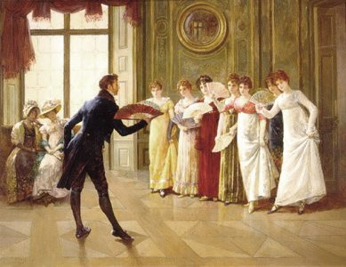London was the centre of the Regency universe. The Season began with the opening of Parliament, usually in March and lasted until late June, when the haut ton fledto their country estates. Young girls made their "come out" to the aged Queen, and then started off on the great husband hunt. Women visited with their friends, patronized the fashionable shops and showed off their finery at lavish halls, the theatre and the opera. Gentlemen, when not busy at their clubs, courted the ladies and pursued "manly" sports.

Life during the Regency was not all glamor and excitement. Dickens' descriptions of the miserable conditions in the Victorian slums are equally applicable to the Regency. Social reformers worked for prison reform and changes in the poor laws, while evangelical religions gained in popularity. There was growing agitation for political reform from both the rising middle class and the increasingly vocal labourers.

George III died in 1820 and Prinny ascended to the throne as George IV. He reigned only 10 years; upon his death in 1830, his next living brother became William IV. When he died in 1837, he was succeeded by the child of his predeceased younger brother - the Princess Victoria. Born in the waning years of the Regency (1819), she reigned as Queen until 1901.

**Literary characteristics**

The Regency period was the heyday of the Romantic poets, led by the scandalous Byron and Shelley and the more mild-mannered Keats. Sir Walter Scott, who began writing epic poetry, turned his hand to historical novels such as Waverly and Ivanhoe. And Jane Austen delighted the country with her timeless accounts of the manners and morals of the Regency era.

A marriage based on love was rarely an option for most women in the British Regency, as securing a steady and sufficient income was the first consideration for both the woman and her family. This is most likely why this period yielded so many examples of literary romance: it gave many women the opportunity to live vicariously through the novel's heroine, who generally married someone she loved deeply.

**Jane Austen**

**Jane Austen** (16 December 1775 - 18 July 1817) was an English novelist whose works of romantic fiction, set among the landed gentry, earned her a place as one of the most widely read writers in English literature. Her realism, biting irony and social commentary have gained her historical importance among scholars and critics.

**Pride and Prejudice**

**From: Pride and Prejudice, by Jane Austen**

**Chapter 1**

It is a truth universally acknowledged, that a single man in possession of a good fortune, must be in want of a wife.

However little known the feelings or views of such a man may be on his first entering a neighbourhood, this truth is so well fixed in the minds of the surrounding families, that he is considered the rightful property of some one or other of their daughters.

"My dear Mr. Bennet," said his lady to him one day, "have you heard that Netherfield Park is let at last?"

Mr. Bennet replied that he had not.

"But it is," returned she; "for Mrs. Long has just been here, and she told me all about it."

Mr. Bennet made no answer.

"Do you not want to know who has taken it?" cried his wife impatiently.

"*You* want to tell me, and I have no objection to hearing it."

This was invitation enough.

"Why, my dear, you must know, Mrs. Long says that Netherfield is taken by a young man of large fortune from the north of England; that he came down on Monday in a chaise and four to see the place, and was so much delighted with it, that he agreed with Mr. Morris immediately; that he is to take possession before Michaelmas[16], and some of his servants are to be in the house by the end of next week."

"What is his name?"

"Bingley."

"Is he married or single?"

"Oh! Single, my dear, to be sure! A single man of large fortune; four or five thousand a year. What a fine thing for our girls!"

"How so? How can it affect them?"

"My dear Mr. Bennet," replied his wife, "how can you be so tiresome! You must know that I am thinking of his marrying one of them."

"Is that his design in settling here?"

"Design! Nonsense, how can you talk so! But it is very likely that he *may* fall in love with one of them, and therefore you must visit him as soon as he comes."

"I see no occasion for that. You and the girls may go, or you may send them by themselves, which perhaps will be still better, for as you are as handsome as any of them, Mr. Bingley may like you the best of the party."

"My dear, you flatter me. I certainly *have* had my share of beauty, but I do not pretend to be anything extraordinary now. When a woman has five grown-up daughters, she ought to give over thinking of her own beauty."

"In such cases, a woman has not often much beauty to think of."

"But, my dear, you must indeed go and see Mr. Bingley when he comes into the neighbourhood."

"It is more than I engage for, I assure you."

"But consider your daughters. Only think what an establishment it would be for one of them. Sir William and Lady Lucas are determined to go, merely on that account, for in general, you know, they visit no newcomers. Indeed you must go, for it will be impossible for *us* to visit him if you do not."

"You are over-scrupulous, surely. I dare say Mr. Bingley will be very glad to see you; and I will send a few lines by you to assure him of my hearty consent to his marrying whichever he chooses of the girls; though I must throw in a good word for my little Lizzy."

"I desire you will do no such thing. Lizzy is not a bit better than the others; and I am sure she is not half so handsome as Jane, nor half so good-humoured as Lydia. But you are always giving *her* the preference."

"They have none of them much to recommend them," replied he; "they are all silly and ignorant like other girls; but Lizzy has something more of quickness than her sisters."

"Mr. Bennet, how *can* you abuse your own children in such a way? You take delight in vexing me. You have no compassion for my poor nerves."

"You mistake me, my dear. I have a high respect for your nerves. They are my old friends. I have heard you mention them with consideration these last twenty years at least."

"Ah, you do not know what I suffer."

"But I hope you will get over it, and live to see many young men of four thousand a year come into the neighbourhood."

"It will be no use to us, if twenty such should come, since you will not visit them."

"Depend upon it, my dear, that when there are twenty, I will visit them all."

Mr. Bennet was so odd a mixture of quick parts, sarcastic humour, reserve, and caprice, that the experience of three-and-twenty years had been insufficient to make his wife understand his character. *Her* mind was less difficult to develop. She was a woman of mean understanding, little information, and uncertain temper. When she was discontented, she fancied herself nervous. The business of her life was to get her daughters married; its solace was visiting and news.

<https://www.youtube.com/watch?v=fMt1Fu7-Pp4>

**Assignments**

1. Afbeelding met persoon, boom, buiten, staand

   Automatisch gegenereerde beschrijvingA. *“It is a truth universally acknowledged, that a single man in possession of a good fortune, must be in want of a wife.”* This first line has become one of the most famous in English literature. In addition to setting the narrative in motion, how does this line alert us to the tone of the novel and our role, as readers, in appreciating it?

B. What does the line imply about women?

C. How does this line set up the theme of love versus marriage?

1. What does Mrs. Bennet want her husband to do?
2. Who would agree that "a single man in possession of a good fortune, must be in want of a wife"? Why does he/she think so?
3. What does Mrs. Bennet consider to be her mission in life?
4. Why does Mr. Bennet favor Lizzy?
5. Mention a few jokes that Mr Bennet makes at the expense of his wife. Does she share his sense of humor?
6. What does Chapter 1 of Pride and Prejudice reveal about the relationship between Mr. and Mrs. Bennet, and why is it important to the novel?

**The Victorian Period**

**Charles Dickens’ Oliver Twist**

**History**

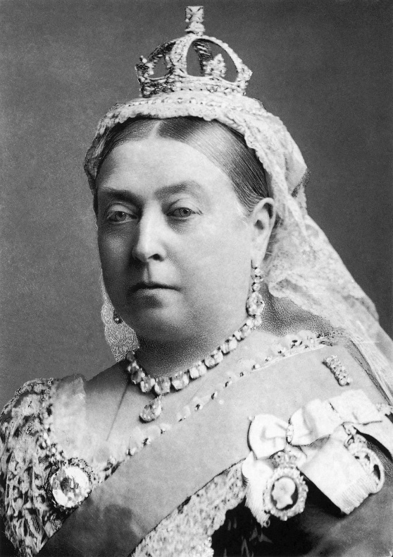The nineteenth century saw England at the heights of its powers. Never before had its economic and military strength been so impressive, and never before had the country played such a prominent role in world affairs. Britannia truly ruled the waves, and London was the proud capital of an empire where the sun never set, ruled over by a woman who was to give her name to one of the greatest periods in British history: the Victorian Age. When she came to the throne in 1837 she found a country where trade and industry were flourishing, and whose bankers, merchants and manufacturers saw the globe as their province. The Industrial Revolution, which had started in the later eighteenth century, had made Britain the first industrialized country in the world. New inventions such as the steam engine and the railway helped to create new chances for increased productivity, and the Victorians made full use of them. The Midlands were now the most advanced industrial area in Europe; Britain had become the ‘workshop of the world’.

In view of all this it is scarcely surprising that many Englishmen were inspired with a strong sense of pride, optimism and self-confidence. They had never had it so good. Some of them, that is. For prosperity had been achieved at a cost. The Industrial Revolution had caused drastic changes in the structure of English society. It had given some ambitious, enterprising people opportunities to make a fortune; but it had also created a huge industrial proletariat, living in vast slum areas in the most miserable conditions. Industrialization had boosted the prosperity of the country as a whole, but it had also widened the gap between the rich and the poor. Many people at the time realized that the whole framework of society was in danger of collapsing if nothing was done to improve the plight of the poorer classes. The urgency of the problem led to many demands for social reform, not only from discontented workers, but also from the higher classes of society. The result was a number of Reform Bills over a period of time, dealing with a variety of subjects including child labour, a reduction of working hours, basic education and the right to vote. Even though such measures were often little more than first steps, they did bring about considerable improvements.

Politically and economically, then, the Victorian Age was a period of growth and expansion and generally the spirit of the age was one of optimism and confidence in what man could achieve. In other areas, however, new developments were more disturbing. The findings of modern Science did not always run parallel with traditional beliefs. The publication of Charles Darwin’s Origin of Species in 1859 caused widespread controversy. Some people saw the theory of evolution as one more illustration of the popular idea of progress and perfectibility, but for many others it questioned the things they had always believed in: the biblical account of the creation of the world, man’s place in the universe, even the very foundations of religion itself. Evolution became the subject of countless ‘angel-or-ape’ disputes, and for many Victorians it meant doubt and anxiety, uncertainty and pessimism.

Queen Victoria died in 1901, and her death marked the end of an era. The world had changed; other countries had emerged as powerful economic and military rivals. The glorious days of English supremacy in the world were coming to an end. Few people realized it at the time, and those who said so were not believed. It took a world war to bring their message home.

**Literary Characteristics**

Most of the developments sketched above are reflected in the literature of the time. The nineteenth century is **the age of the novel**. Audiences were larger than ever before, partly due to improved education but especially to the **instalment system**, in which novels appeared in cheap weekly or monthly parts before being published complete. A host of major and minor novelists set out to satisfy the tastes of the **middle classes** who now formed the backbone of society; among them were Dickens and the Brontë sisters, whose work is discussed in detail in the following chapters.

In their descriptions of contemporary society, most authors show at least an awareness of the **social problems of the day**. Dickens in particular had a genuine concern for the **poorer classes**, and in his early novels he consciously uses his powers as a novelist to show the need for **social reform**.

**Charles Dickens**

Charles Dickens was born in Portsmouth, where his father was a clerk in the Navy Pay Office. John Dickens was a friendly, hard-working man, but totally unable to live within his income. Later, in his partly autobiographical novel David Copperfield, Dickens was to present him in the figure of Mr Micawber, a kind but irresponsible optimist, who, in spite of the fact that he is always short of money, remains confident that ‘something will turn up’.

By the time Charles was twelve, the family had moved to London. His father’s spending habits had once more got him into trouble, and he was arrested for debts and taken to the Marshalsea Prison. It was decided that in order to bring in some money Charles should leave school and go to work at Warren’s Blacking Factory, where his job was pasting labels on bottles at six shillings a week. Even though this period lasted only for a couple of months, it was of tremendous importance. The experiences in the blacking warehouse, and the deep sense of shame they inspired, were to haunt Dickens for the rest of his life.

When his father inherited enough money to pay his debts and was released from prison, Charles left the blacking factory. After a job as a clerk at a lawyer’s office he became a parliamentary reporter and occasionally wrote articles and stories for various papers. His first great success as a novelist came with *The Pickwick Papers*. It was published in cheap monthly parts, a method that brought him a large audience among all social classes, and one he was to use for the greater part of his later works.

With new chapters of Pickwick still appearing in print, Dickens started upon *Oliver Twist*, the first of his attacks on social wrongs in early Victorian England. The book established his reputation as asocial reformer, and made him the most popular novelist of his days.

During the years that followed Dickens produced an impressive number of books, including *Nicholas Nickleby, A Christmas Carol, David Copperfield, Hard Times, Great Expectations* and many others. He started giving highly successful public readings from his own works, combining his talents as a writer and as an actor. In the course of the eighteen sixties his health began to give way under the pressure of his work. His last novel, The Mystery of Edwin Drood remained unfinished; on June 8, 1870, he suffered a stroke and died the following day. He was buried in the Poets’ Corner of Westminster Abbey.

***Oliver Twist***

*Oliver Twist* is the second novel by English author [Charles Dickens](https://en.wikipedia.org/wiki/Charles_Dickens). It was originally published as a [serial](https://en.wikipedia.org/wiki/Serial_(literature)) from 1837 to 1839 and as a three-volume book in 1838. The story follows the [titular orphan](https://en.wikipedia.org/wiki/Oliver_Twist_(character)), who, after being raised in a [workhouse](https://en.wikipedia.org/wiki/Workhouse), escapes to London, where he meets a gang of juvenile pickpockets led by the elderly criminal [Fagin](https://en.wikipedia.org/wiki/Fagin), discovers the secrets of his parentage, and reconnects with his remaining family. Oliver Twist unromantically portrays the sordid lives of criminals and exposes the cruel treatment of the many orphans in London in the mid-19th century.

Oliver Twist is a so-called a coming-of-age story. A coming-of-age story, also called a Bildungsroman, is about the protagonist’s journey from childhood innocence to experience and education: from being a child to being an adult, from being naïve to being wise, from being immature to being mature. There will usually be pain and suffering along the way, because growing up isn’t easy. It is a common form, and Dickens wrote more than one Bildungsroman: *Great Expectations*, *Oliver Twist* (1838) and *David Copperfield* (1850). A modern Bildungsroman is J. K. Rowling’s *Harry Potter* series (1997–2007). A Bildungsroman has distinct features:

* There is a **sensitive main** character who searches for answers to life’s problems.
* The story may begin with an **emotional loss** or difficulty.
* The main character sets out to **explore the world** and leaves his/her childhood world.
* The **goal** of this character is to be a mature, knowledgeable adult.
* There is often **conflict** with the world.
* The main character often **helps others at the end** of the novel because of all he/she has learnt.

**Charles Dickens’ *Oliver Twist***

## **CHAPTER I. TREATS OF THE PLACE WHERE OLIVER TWIST WAS BORN AND OF THE CIRCUMSTANCES ATTENDING HIS BIRTH**

Among other public buildings in a certain town, which for many reasons it will be prudent to refrain from mentioning, and to which I will assign no fictitious name, there is one anciently common to most towns, great or small: to wit, a workhouse[17]; and in this workhouse was born; on a day and date which I need not trouble myself to repeat, inasmuch as it can be of no possible consequence to the reader, in this stage of the business at all events; the item of mortality whose name is prefixed to the head of this chapter.

For a long time after it was ushered into this world of sorrow and trouble, by the parish[18] surgeon, it remained a matter of considerable doubt whether the child would survive to bear any name at all; in which case it is somewhat more than probable that these memoirs would never have appeared; or, if they had, that being comprised within a couple of pages, they would have possessed the inestimable merit of being the most concise and faithful specimen of biography, extant in the literature of any age or country.

Although I am not disposed to maintain that the being born in a workhouse, is in itself the most fortunate and enviable circumstance that can possibly befall a human being, I do mean to say that in this particular instance, it was the best thing for Oliver Twist that could by possibility have occurred. The fact is, that there was considerable difficulty in inducing Oliver to take upon himself the office of respiration,—a troublesome practice, but one which custom has rendered necessary to our easy existence; and for some time he lay gasping on a little flock mattress, rather unequally poised between this world and the next: the balance being decidedly in favour of the latter. Now, if, during this brief period, Oliver had been surrounded by careful grandmothers, anxious aunts, experienced nurses, and doctors of profound wisdom, he would most inevitably and indubitably have been killed in no time. There being nobody by, however, but a pauper old woman, who was rendered rather misty by an unwonted allowance of beer; and a parish surgeon who did such matters by contract; Oliver and Nature fought out the point between them. The result was, that, after a few struggles, Oliver breathed, sneezed, and proceeded to advertise to the inmates of the workhouse the fact of a new burden having been imposed upon the parish[19], by setting up as loud a cry as could reasonably have been expected from a male infant who had not been possessed of that very useful appendage, a voice, for a much longer space of time than three minutes and a quarter.

As Oliver gave this first proof of the free and proper action of his lungs, the patchwork coverlet which was carelessly flung over the iron bedstead, rustled; the pale face of a young woman was raised feebly from the pillow; and a faint voice imperfectly articulated the words, “Let me see the child, and die.”

The surgeon had been sitting with his face turned towards the fire: giving the palms of his hands a warm and a rub alternately. As the young woman spoke, he rose, and advancing to the bed’s head, said, with more kindness than might have been expected of him:

“Oh, you must not talk about dying yet.”

“Lor bless her dear heart, no!” interposed the nurse, hastily depositing in her pocket a green glass bottle, the contents of which she had been tasting in a corner with evident satisfaction.

“Lor bless her dear heart, when she has lived as long as I have, sir, and had thirteen children of her own, and all on ’em dead except two, and them in the wurkus with me, she’ll know better than to take on in that way, bless her dear heart! Think what it is to be a mother, there’s a dear young lamb do.”

Apparently this consolatory perspective of a mother’s prospects failed in producing its due effect. The patient shook her head, and stretched out her hand towards the child.

The surgeon deposited it in her arms. She imprinted her cold white lips passionately on its forehead; passed her hands over her face; gazed wildly round; shuddered; fell back—and died. They chafed her breast, hands, and temples; but the blood had stopped forever. They talked of hope and comfort. They had been strangers too long.

“It’s all over, Mrs. Thingummy!” said the surgeon at last.

“Ah, poor dear, so it is!” said the nurse, picking up the cork of the green bottle, which had fallen out on the pillow, as she stooped to take up the child. “Poor dear!”

“You needn’t mind sending up to me, if the child cries, nurse,” said the surgeon, putting on his gloves with great deliberation. “It’s very likely it *will* be troublesome. Give it a little gruel[20] if it is.” He put on his hat, and, pausing by the bed-side on his way to the door, added, “She was a good-looking girl, too; where did she come from?”

“She was brought here last night,” replied the old woman, “by the overseer’s order. She was found lying in the street. She had walked some distance, for her shoes were worn to pieces; but where she came from, or where she was going to, nobody knows.”

The surgeon leaned over the body, and raised the left hand. “The old story,” he said, shaking his head: “no wedding-ring, I see. Ah! Good-night!”

The medical gentleman walked away to dinner; and the nurse, having once more applied herself to the green bottle, sat down on a low chair before the fire, and proceeded to dress the infant.

What an excellent example of the power of dress, young Oliver Twist was! Wrapped in the blanket which had hitherto formed his only covering, he might have been the child of a nobleman or a beggar; it would have been hard for the haughtiest stranger to have assigned him his proper station in society. But now that he was enveloped in the old calico robes which had grown yellow in the same service, he was badged and ticketed, and fell into his place at once—a parish child—the orphan of a workhouse—the humble, half-starved drudge—to be cuffed and buffeted through the world—despised by all, and pitied by none.

Oliver cried lustily. If he could have known that he was an orphan, left to the tender mercies of church-wardens and overseers, perhaps he would have cried the louder.

## **CHAPTER II. TREATS OF OLIVER TWIST’S GROWTH, EDUCATION, AND BOARD**

For the next eight or ten months, Oliver was the victim of a systematic course of treachery and deception. He was brought up by hand. The hungry and destitute situation of the infant orphan was duly reported by the workhouse authorities to the parish authorities. The parish authorities inquired with dignity of the workhouse authorities, whether there was no female then domiciled in “the house” who was in a situation to impart to Oliver Twist, the consolation and nourishment of which he stood in need. The workhouse authorities replied with humility, that there was not. Upon this, the parish authorities magnanimously and humanely resolved, that Oliver should be “farmed,” or, in other words, that he should be dispatched to a branch-workhouse some three miles off, where twenty or thirty other juvenile offenders against the poor-laws, rolled about the floor all day, without the inconvenience of too much food or too much clothing, under the parental superintendence of an elderly female, who received the culprits at and for the consideration of sevenpence-halfpenny per small head per week. Sevenpence-halfpenny’s worth per week is a good round diet for a child; a great deal may be got for sevenpence-halfpenny, quite enough to overload its stomach, and make it uncomfortable. The elderly female was a woman of wisdom and experience; she knew what was good for children; and she had a very accurate perception of what was good for herself. So, she appropriated the greater part of the weekly stipend to her own use, and consigned the rising parochial generation to even a shorter allowance than was originally provided for them. Thereby finding in the lowest depth a deeper still; and proving herself a very great experimental philosopher.

Everybody knows the story of another experimental philosopher who had a great theory about a horse being able to live without eating, and who demonstrated it so well, that he had got his own horse down to a straw a day, and would unquestionably have rendered him a very spirited and rampacious animal on nothing at all, if he had not died, four-and-twenty hours before he was to have had his first comfortable bait of air. Unfortunately for the experimental philosophy of the female to whose protecting care Oliver Twist was delivered over, a similar result usually attended the operation of *her* system; for at the very moment when the child had contrived to exist upon the smallest possible portion of the weakest possible food, it did perversely happen in eight and a half cases out of ten, either that it sickened from want and cold, or fell into the fire from neglect, or got half-smothered by accident; in any one of which cases, the miserable little being was usually summoned into another world, and there gathered to the fathers it had never known in this.

Occasionally, when there was some more than usually interesting inquest upon a parish child who had been overlooked in turning up a bedstead, or inadvertently scalded to death when there happened to be a washing—though the latter accident was very scarce, anything approaching to a washing being of rare occurrence in the farm—the jury would take it into their heads to ask troublesome questions, or the parishioners would rebelliously affix their signatures to a remonstrance. But these impertinences were speedily checked by the evidence of the surgeon, and the testimony of the beadle[21]; the former of whom had always opened the body and found nothing inside (which was very probable indeed), and the latter of whom invariably swore whatever the parish wanted; which was very self-devotional. Besides, the board made periodical pilgrimages to the farm, and always sent the beadle the day before, to say they were going. The children were neat and clean to behold, when *they* went; and what more would the people have!

It cannot be expected that this system of farming would produce any very extraordinary or luxuriant crop. Oliver Twist’s ninth birthday found him a pale thin child, somewhat diminutive in stature, and decidedly small in circumference. But nature or inheritance had implanted a good sturdy spirit in Oliver’s breast. It had had plenty of room to expand, thanks to the spare diet of the establishment; and perhaps to this circumstance may be attributed his having any ninth birth-day at all. Be this as it may, however, it was his ninth birthday; and he was keeping it in the coal-cellar with a select party of two other young gentleman, who, after participating with him in a sound thrashing, had been locked up for atrociously presuming to be hungry, when Mrs. Mann, the good lady of the house, was unexpectedly startled by the apparition of Mr. Bumble, the beadle, striving to undo the wicket of the garden-gate.

“Goodness gracious! Is that you, Mr. Bumble, sir?” said Mrs. Mann, thrusting her head out of the window in well-affected ecstasies of joy. “(Susan, take Oliver and them two brats upstairs, and wash ’em directly.)—My heart alive! Mr. Bumble, how glad I am to see you, sure-ly!”

Now, Mr. Bumble was a fat man, and a choleric[22]; so, instead of responding to this open-hearted salutation in a kindred spirit, he gave the little wicket a tremendous shake, and then bestowed upon it a kick which could have emanated from no leg but a beadle’s.

“Lor, only think,” said Mrs. Mann, running out,—for the three boys had been removed by this time,—“only think of that! That I should have forgotten that the gate was bolted on the inside, on account of them dear children! Walk in sir; walk in, pray, Mr. Bumble, do, sir.”

Although this invitation was accompanied with a curtsey[23] that might have softened the heart of a church-warden[24], it by no means mollified[25] the beadle.

“Do you think this respectful or proper conduct, Mrs. Mann,” inquired Mr. Bumble, grasping his cane, “to keep the parish officers a waiting at your garden-gate, when they come here upon porochial business with the porochial orphans? Are you aweer, Mrs. Mann, that you are, as I may say, a porochial delegate, and a stipendiary?”

“I’m sure Mr. Bumble, that I was only a telling one or two of the dear children as is so fond of you, that it was you a coming,” replied Mrs. Mann with great humility[26].

Mr. Bumble had a great idea of his oratorical powers and his importance. He had displayed the one, and vindicated[27] the other. He relaxed.

“Well, well, Mrs. Mann,” he replied in a calmer tone; “it may be as you say; it may be. Lead the way in, Mrs. Mann, for I come on business, and have something to say.”

Mrs. Mann ushered the beadle into a small parlour with a brick floor; placed a seat for him; and officiously deposited his cocked hat and cane on the table before him. Mr. Bumble wiped from his forehead the perspiration which his walk had engendered, glanced complacently at the cocked hat, and smiled. Yes, he smiled. Beadles are but men: and Mr. Bumble smiled.

“Now don’t you be offended at what I’m a going to say,” observed Mrs. Mann, with captivating sweetness. “You’ve had a long walk, you know, or I wouldn’t mention it. Now, will you take a little drop of somethink, Mr. Bumble?”

“Not a drop. Nor a drop,” said Mr. Bumble, waving his right hand in a dignified, but placid manner.

“I think you will,” said Mrs. Mann, who had noticed the tone of the refusal, and the gesture that had accompanied it. “Just a leetle drop, with a little cold water, and a lump of sugar.”

Mr. Bumble coughed.

“Now, just a leetle drop,” said Mrs. Mann persuasively.

“What is it?” inquired the beadle.

“Why, it’s what I’m obliged to keep a little of in the house, to put into the blessed infants’ Daffy, when they ain’t well, Mr. Bumble,” replied Mrs. Mann as she opened a corner cupboard, and took down a bottle and glass. “It’s gin. I’ll not deceive you, Mr. B. It’s gin.”

“Do you give the children Daffy[28], Mrs. Mann?” inquired Bumble, following with his eyes the interesting process of mixing.

“Ah, bless ’em, that I do, dear as it is,” replied the nurse. “I couldn’t see ’em suffer before my very eyes, you know sir.”

“No”; said Mr. Bumble approvingly; “no, you could not. You are a humane woman, Mrs. Mann.” (Here she set down the glass.) “I shall take a early opportunity of mentioning it to the board, Mrs. Mann.” (He drew it towards him.) “You feel as a mother, Mrs. Mann.” (He stirred the gin-and-water.) “I—I drink your health with cheerfulness, Mrs. Mann”; and he swallowed half of it.

“And now about business,” said the beadle, taking out a leathern pocket-book. “The child that was half-baptized Oliver Twist, is nine year old to-day.”

“Bless him!” interposed Mrs. Mann, inflaming her left eye with the corner of her apron.

“And notwithstanding a offered reward of ten pound, which was afterwards increased to twenty pound. Notwithstanding the most superlative, and, I may say, supernat’ral exertions on the part of this parish,” said Bumble, “we have never been able to discover who is his father, or what was his mother’s settlement, name, or condition.”

Mrs. Mann raised her hands in astonishment; but added, after a moment’s reflection, “How comes he to have any name at all, then?”

The beadle drew himself up with great pride, and said, “I inwented it.”

“You, Mr. Bumble!”

“I, Mrs. Mann. We name our fondlings in alphabetical order. The last was a S,—Swubble, I named him. This was a T,—Twist, I named *him*. The next one comes will be Unwin, and the next Vilkins. I have got names ready made to the end of the alphabet, and all the way through it again, when we come to Z.”

“Why, you’re quite a literary character, sir!” said Mrs. Mann.

“Well, well,” said the beadle, evidently gratified with the compliment; “perhaps I may be. Perhaps I may be, Mrs. Mann.” He finished the gin-and-water, and added, “Oliver being now too old to remain here, the board have determined to have him back into the house. I have come out myself to take him there. So let me see him at once.”

“I’ll fetch him directly,” said Mrs. Mann, leaving the room for that purpose. Oliver, having had by this time as much of the outer coat of dirt which encrusted his face and hands, removed, as could be scrubbed off in one washing, was led into the room by his benevolent[29] protectress.

“Make a bow to the gentleman, Oliver,” said Mrs. Mann.

Oliver made a bow, which was divided between the beadle on the chair, and the cocked hat on the table.

“Will you go along with me, Oliver?” said Mr. Bumble, in a majestic voice.

Oliver was about to say that he would go along with anybody with great readiness, when, glancing upward, he caught sight of Mrs. Mann, who had got behind the beadle’s chair, and was shaking her fist at him with a furious countenance. He took the hint at once, for the fist had been too often impressed upon his body not to be deeply impressed upon his recollection.

“Will she go with me?” inquired poor Oliver.

“No, she can’t,” replied Mr. Bumble. “But she’ll come and see you sometimes.”

This was no very great consolation to the child. Young as he was, however, he had sense enough to make a feint of feeling great regret at going away. It was no very difficult matter for the boy to call tears into his eyes. Hunger and recent ill-usage are great assistants if you want to cry; and Oliver cried very naturally indeed. Mrs. Mann gave him a thousand embraces, and what Oliver wanted a great deal more, a piece of bread and butter, less he should seem too hungry when he got to the workhouse. With the slice of bread in his hand, and the little brown-cloth parish cap on his head, Oliver was then led away by Mr. Bumble from the wretched home where one kind word or look had never lighted the gloom of his infant years. And yet he burst into an agony of childish grief, as the cottage-gate closed after him. Wretched as were the little companions in misery he was leaving behind, they were the only friends he had ever known; and a sense of his loneliness in the great wide world, sank into the child’s heart for the first time.

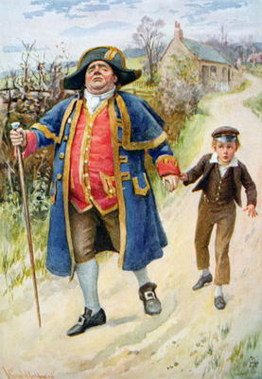Mr. Bumble walked on with long strides; little Oliver, firmly grasping his gold- laced cuff, trotted beside him, inquiring at the end of every quarter of a mile whether they were “nearly there.” To these interrogations Mr. Bumble returned very brief and snappish replies; for the temporary blandness which gin-and-water awakens in some bosoms had by this time evaporated; and he was once again a beadle.

Oliver had not been within the walls of the workhouse a quarter of an hour, and had scarcely completed the demolition of a second slice of bread, when Mr. Bumble, who had handed him over to the care of an old woman, returned; and, telling him it was a board night, informed him that the board had said he was to appear before it forthwith.

Not having a very clearly defined notion of what a live board was, Oliver was rather astounded by this intelligence, and was not quite certain whether he ought to laugh or cry. He had no time to think about the matter, however; for Mr. Bumble gave him a tap on the head, with his cane, to wake him up: and another on the back to make him lively: and bidding him to follow, conducted him into a large white-washed room, where eight or ten fat gentlemen were sitting round a table. At the top of the table, seated in an arm-chair rather higher than the rest, was a particularly fat gentleman with a very round, red face.

“Bow to the board,” said Bumble. Oliver brushed away two or three tears that were lingering in his eyes; and seeing no board but the table, fortunately bowed to that.

“What’s your name, boy?” said the gentleman in the high chair.

Oliver was frightened at the sight of so many gentlemen, which made him tremble: and the beadle gave him another tap behind, which made him cry. These two causes made him answer in a very low and hesitating voice; whereupon a gentleman in a white waistcoat said he was a fool. Which was a capital way of raising his spirits, and putting him quite at his ease.

“Boy,” said the gentleman in the high chair, “listen to me. You know you’re an orphan, I suppose?”

“What’s that, sir?” inquired poor Oliver.

“The boy *is* a fool—I thought he was,” said the gentleman in the white waistcoat.

“Hush!” said the gentleman who had spoken first. “You know you’ve got no father or mother, and that you were brought up by the parish, don’t you?”

“Yes, sir,” replied Oliver, weeping bitterly.

“What are you crying for?” inquired the gentleman in the white waistcoat. And to be sure it was very extraordinary. What *could* the boy be crying for?

“I hope you say your prayers every night,” said another gentleman in a gruff voice; “and pray for the people who feed you, and take care of you—like a Christian.”

“Yes, sir,” stammered the boy. The gentleman who spoke last was unconsciously right. It would have been very like a Christian, and a marvellously good Christian too, if Oliver had prayed for the people who fed and took care of *him*. But he hadn’t, because nobody had taught him.

“Well! You have come here to be educated, and taught a useful trade,” said the red-faced gentleman in the high chair.

“So you’ll begin to pick oakum[30] to-morrow morning at six o’clock,” added the surly one in the white waistcoat.

For the combination of both these blessings in the one simple process of picking oakum, Oliver bowed low by the direction of the beadle, and was then hurried away to a large ward; where, on a rough, hard bed, he sobbed himself to sleep. What a novel illustration of the tender laws of England! They let the paupers go to sleep!

Poor Oliver! He little thought, as he lay sleeping in happy unconsciousness of all around him, that the board had that very day arrived at a decision which would exercise the most material influence over all his future fortunes. But they had. And this was it:

The members of this board were very sage, deep, philosophical men; and when they came to turn their attention to the workhouse, they found out at once, what ordinary folks would never have discovered—the poor people liked it! It was a regular place of public entertainment for the poorer classes; a tavern where there was nothing to pay; a public breakfast, dinner, tea, and supper all the year round; a brick and mortar elysium, where it was all play and no work. “Oho!” said the board, looking very knowing; “we are the fellows to set this to rights; we’ll stop it all, in no time.” So, they established the rule, that all poor people should have the alternative (for they would compel nobody, not they), of being starved by a gradual process in the house, or by a quick one out of it. With this view, they contracted with the water-works to lay on an unlimited supply of water; and with a corn-factor to supply periodically small quantities of oatmeal; and issued three meals of thin gruel a day, with an onion twice a week, and half a roll of Sundays. They made a great many other wise and humane regulations, having reference to the ladies, which it is not necessary to repeat; kindly undertook to divorce poor married people, in consequence of the great expense of a suit in Doctors’ Commons; and, instead of compelling a man to support his family, as they had theretofore done, took his family away from him, and made him a bachelor! There is no saying how many applicants for relief, under these last two heads, might have started up in all classes of society, if it had not been coupled with the workhouse; but the board were long-headed men, and had provided for this difficulty. The relief was inseparable from the workhouse and the gruel; and that frightened people.

For the first six months after Oliver Twist was removed, the system was in full operation. It was rather expensive at first, in consequence of the increase in the undertaker’s bill, and the necessity of taking in the clothes of all the paupers, which fluttered loosely on their wasted, shrunken forms, after a week or two’s gruel. But the number of workhouse inmates got thin as well as the paupers; and the board were in ecstasies.

The room in which the boys were fed, was a large stone hall, with a copper at one end: out of which the master, dressed in an apron for the purpose, and assisted by one or two women, ladled the gruel at mealtimes. Of this festive composition each boy had one porringer, and no more—except on occasions of great public rejoicing, when he had two ounces and a quarter of bread besides.

The bowls never wanted washing. The boys polished them with their spoons till they shone again; and when they had performed this operation (which never took very long, the spoons being nearly as large as the bowls), they would sit staring at the copper, with such eager eyes, as if they could have devoured the very bricks of which it was composed; employing themselves, meanwhile, in sucking their fingers most assiduously, with the view of catching up any stray splashes of gruel that might have been cast thereon. Boys have generally excellent appetites. Oliver Twist and his companions suffered the tortures of slow starvation for three months: at last they got so voracious and wild with hunger, that one boy, who was tall for his age, and hadn’t been used to that sort of thing (for his father had kept a small cook-shop), hinted darkly to his companions, that unless he had another basin of gruel per diem, he was afraid he might some night happen to eat the boy who slept next him, who happened to be a weakly youth of tender age. He had a wild, hungry eye; and they implicitly believed him. A council was held; lots were cast who should walk up to the master after supper that evening, and ask for more; and it fell to Oliver Twist.

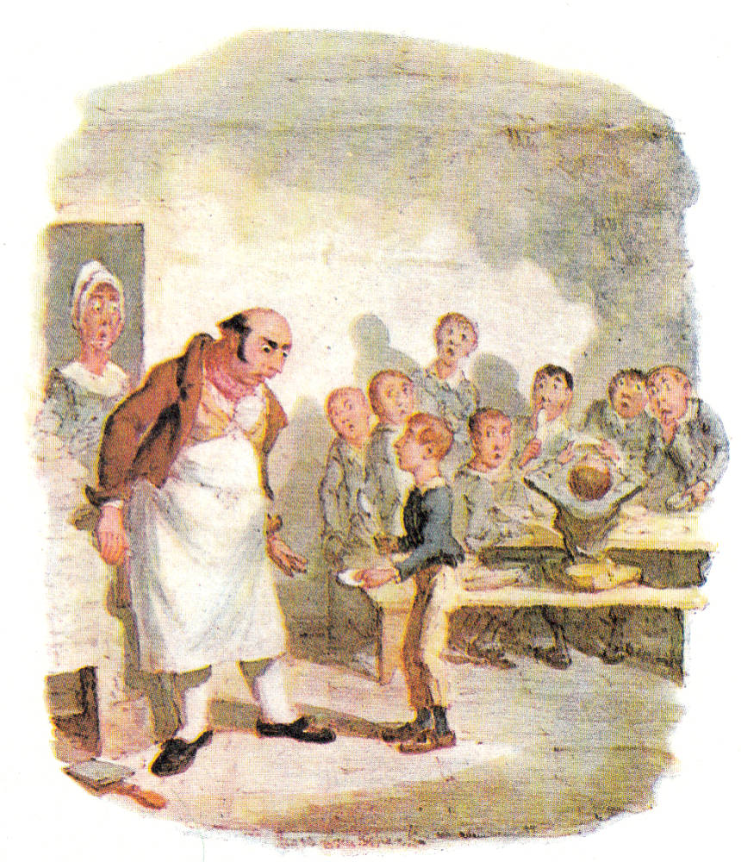The evening arrived; the boys took their places. The master, in his cook’s uniform, stationed himself at the copper; his pauper assistants ranged themselves behind him; the gruel was served out; and a long grace was said over the short commons. The gruel disappeared; the boys whispered each other, and winked at Oliver; while his next neighbors nudged him. Child as he was, he was desperate with hunger, and reckless with misery. He rose from the table; and advancing to the master, basin and spoon in hand, said: somewhat alarmed at his own temerity:

“Please, sir, I want some more.”

The master was a fat, healthy man; but he turned very pale. He gazed in stupefied astonishment on the small rebel for some seconds, and then clung for support to the copper. The assistants were paralysed with wonder; the boys with fear.

“What!” said the master at length, in a faint voice.

“Please, sir,” replied Oliver, “I want some more.”

The master aimed a blow at Oliver’s head with the ladle; pinioned him in his arm; and shrieked aloud for the beadle.

The board were sitting in solemn conclave, when Mr. Bumble rushed into the room in great excitement, and addressing the gentleman in the high chair, said,

“Mr. Limbkins, I beg your pardon, sir! Oliver Twist has asked for more!”

There was a general start. Horror was depicted on every countenance.

“For *more*!” said Mr. Limbkins. “Compose yourself, Bumble, and answer me distinctly. Do I understand that he asked for more, after he had eaten the supper allotted by the dietary?”

“He did, sir,” replied Bumble.

“That boy will be hung,” said the gentleman in the white waistcoat. “I know that boy will be hung.”

Nobody controverted the prophetic gentleman’s opinion. An animated discussion took place. Oliver was ordered into instant confinement; and a bill was next morning pasted on the outside of the gate, offering a reward of five pounds to anybody who would take Oliver Twist off the hands of the parish. In other words, five pounds and Oliver Twist were offered to any man or woman who wanted an apprentice to any trade, business, or calling.

“I never was more convinced of anything in my life,” said the gentleman in the white waistcoat, as he knocked at the gate and read the bill next morning: “I never was more convinced of anything in my life, than I am that that boy will come to be hung.”

**Assignments**

**Read Chapter 1, then answer the following questions:**

1. What does the narrator mean by “the item of mortality whose name is prefixed to the head of this chapter” in paragraph 1?
2. Where was Oliver born?
3. Who were present at his birth and what do you know about them?
4. What do you know about Oliver’s mother? What happens to her?

**Read Chapter 2, then answer the following questions:**

1. Why is Oliver thin and pale?
2. ‘Irony’ may be defined as ‘expressing your meaning by stating the opposite of what you really want to say, for humorous effect or to make the statement more forceful’. Irony is one of the most striking features of Dickens’s style, and this is especially clear in this extract. For example, Mrs Mann is called Oliver’s ‘benevolent protectress’, but the context proves that she does not protect the boys at all, to say the least. Similarly, Chapter 1 ends by stating that Oliver is said to be ‘left to the *tender* mercies of churchwardens and overseers’. Can you find at least five other examples of this use of irony?
3. What do the gentlemen on the board look like? And what about the master who serves out the gruel? Why does Dickens stress this aspect of their appearance? What criticism is implied here?
4. Can you describe Oliver’s character?
5. Is the reader on Oliver's side? Why do you think that?
6. Which aspects of the coming-of-age novel do you find in these excerpts? Give evidence.

1. Start rhyme
2. a mead hall or feasting hall was a large building with a single room intended to receive guests and serve as a center of community social life. 
3. a large burial mound of earth or stones.
4. The King of England, Edward the Confessor, had died childless.
5. From Normandy, France.
6. Harold Godwinson, an English nobleman who had claimed the throne of Edward’s death. Edward, though, had meant William of Normandy to be his successor.
7. a frame story is a narrative that frames or surrounds another story or set of stories. It usually appears at the beginning and end of that larger story and provides important context and key information for how to read it. Example of frame stories: The Canterbury Tales, Titanic (film), Life of Pi.
8. **Satire:**a work of fiction that uses irony and humour to mock and criticise vanity, folly, and social issues.
9. Archaic language (words that are no longer in use): regiment of foot = infantry
10. Gout is a common and complex form of arthritis that can affect anyone.
11. To express disagreement or complaint
12. used, [especially](https://dictionary.cambridge.org/dictionary/english/especially) in written [English](https://dictionary.cambridge.org/dictionary/english/english), when you [want](https://dictionary.cambridge.org/dictionary/english/want) to give more [detail](https://dictionary.cambridge.org/dictionary/english/detail) or be more [exact](https://dictionary.cambridge.org/dictionary/english/exact) about something you have just written. Viz. = namely. Archaic language.
13. to [express](https://dictionary.cambridge.org/dictionary/english/express) [sadness](https://dictionary.cambridge.org/dictionary/english/sadness) and [feeling](https://dictionary.cambridge.org/dictionary/english/feeling) [sorry](https://dictionary.cambridge.org/dictionary/english/sorry) about something
14. Unreciprocated or unrequited love is when you long for someone who doesn't share your sentiments.
15. hyperbole is an exaggeration. Hyperboles are used in poetry and prose for more emphasis or to express strong emotions.
16. also known as the *Feast of Saints Michael, Gabriel, and Raphael*, *the Feast of the Archangels, or the Feast of Saint Michael and All Angels*. It is a [Christian](https://en.wikipedia.org/wiki/Christianity) festival observed in some Western [liturgical calendars](https://en.wikipedia.org/wiki/Liturgical_year) on 29 September.
17. a public institution in which the poor of a parish received board and lodging in return for work.
18. a small administrative district typically having its own church and a priest or pastor.
19. a small administrative district typically having its own church and a priest or pastor.
20. a thin liquid food of oatmeal or other meal boiled in milk or water.
21. a ceremonial officer of a church, college, or similar institution.
22. bad-tempered or irritable
23. a woman's or girl's formal greeting made by bending the knees with one foot in front of the other.
24. is a [lay](https://en.wikipedia.org/wiki/Laity) official in a [parish](https://en.wikipedia.org/wiki/Parish) or congregation of the [Anglican Communion](https://en.wikipedia.org/wiki/Anglicanism) or [Catholic Church](https://en.wikipedia.org/wiki/Catholicism), usually working as a part-time volunteer.
25. appease the anger or anxiety of (someone).
26. the quality of having a modest or low view of one's importance.
27. show or prove to be right, reasonable, or justified.
28. a medicine for children, named for a seventeenth-century clergyman. It consisted of senna (a laxative prepared from the roots of the cassia tree) and was commonly mixed with gin.
29. well meaning and kindly.
30. loose fibre obtained by untwisting old rope.